PRODUCT DATA SHEET

G


SL-NT C
NON-TOXIC
CRYOGENIC GREASE

PRODUCT DESCRIPTION

SL-NT-C is the newest member of the well-known Sentinel family of food grade lubricants.
SL-NT-C is a multi-purpose synthetic, extreme low temperature, non-toxic, water white, tasteless, and odorless grease. SL-NT-C is a synthetically thickened grease which employs an extremely low viscosity Polyalphaolefin (PAO) based fluid.
Its low temperature torque characteristic at -73°C (-100°F) is a functional benefit that conventional greases cannot achieve.

SL-NT-C complies with FDA regulations Title 21, CFR 178.3570 and is registered with NSF for use in food processing plants. SL-NT-C has received an H-1 rating.

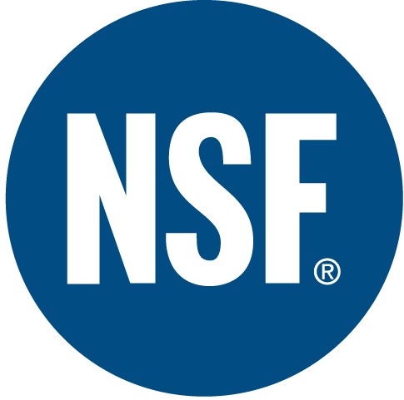

TYPICAL CHARACTERISTICS

NLGI Grade 1½ ASTM D-1092
Worked Penetration 290-315 ASTM D- 217
Dropping Point None ASTM D-2265
Oxidation Stability -2 ASTM D- 942
Psi Drop @ 100 hrs
Rust Preventative 1a ASTM D-1743
Water Washout 2.0 ASTM D-1264
Extreme Pressure 20+ (45) ASTM D-2509
Timken OK Load Kg (Lb)
Four Ball Wear .7mm ASTM D-2266
Food Grade Status H1 NSF
NSF Registration 140316
Appearance Clear, Smooth

PIN # 06540

TO ORDER or FOR ADDITIONAL INFORMATION



