PRODUCT DATA SHEET

G
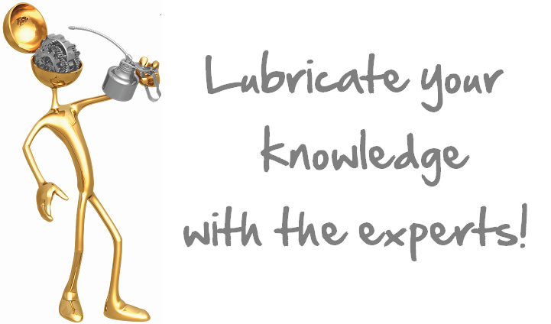
ANTI-SEIZE
EXTREME PRESSURE

PRODUCT DESCRIPTION

Sentinel’s Anti-Seize is a synthetic multi-purpose E.P. Lubricant. It may be used in production machinery (sliding surfaces of reciprocating parts), machine shops, tool and die manufacturing, chemical industry applications, metal working and general industry. Sentinel’s Anti-Seize will prevent corrosion and provide excellent lubrication on parts exposed to water, steam and most acids or alkalis.

Sentinel’s Anti-Seize is a highly concentrated, stable, non-melting molybdenum disulfide compound. It is impervious to water and is not affected by most acids or alkalis.

Sentinel’s Anti-Seize has excellent lubricating qualities from -150˚C (-300˚F) to over 954˚C (1750˚F). It has a high film strength, low coefficient of friction and a tenacious adherence to metal surfaces.

Sentinel’s Anti-Seize reduces wear and prevents seizing and galling on all extreme applications.

TYPICAL CHARACTERISTICS

NLGI Grade 3 ASTM D-1092
Worked Penetration 220-250 ASTM D- 217
Dropping Point None ASTM D-2265
Oxidation Stability -1 ASTM D- 942
Psi Drop @ 100 hrs
Rust Preventative 1a ASTM D-1743
Water Washout 0.8 ASTM D-1264
Extreme Pressure 50+ (110) ASTM D-2509
Timken OK Load Kg (Lb)
Four Ball Wear .5mm ASTM D-2266
Solids MoS₂
USDA Rating H-2
Appearance Dark Metallic

PIN # 03193

TO ORDER or FOR ADDITIONAL INFORMATION



