PRODUCT DATA SHEET

G


S NT AA1 OIL
NON-TOXIC GENERAL
PURPOSE EDIBLE OILS

PRODUCT DESCRIPTION

S-NT-AA1 Oil Series is a special, highly refined, water white blend of U.S.P. fluid treated with synthetic compounds to produce a stable high film strength lubricant surpassing the highest purity standards. S-NT-AA1 Oil Series is formulated to comply with FDA requirements for use in food, drug and cosmetic industries.

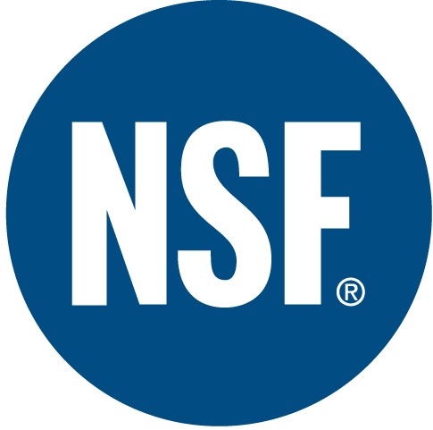

It is approved by the USDA and NSF with an H-1 rating for incidental contact with food products in Federally Inspected Meat and Poultry Plants. It surpasses all U.S.P. requirements, and is, therefore acceptable for internal ingestion.

S-NT-AA1 Oil Series is free of unsaturated components and possesses a high degree of chemical stability. It is suitable for plain and ball bearing applications where non-toxic oil are required. It can be applied by drip cup, mist spray, brush or other mechanical means.

TO ORDER or FOR ADDITIONAL INFORMATION



S NT AA1 OIL
NON-TOXIC GENERAL
PURPOSE EDIBLE OILS

TYPICAL CHARACTERISTICS

S-NT-AA1 Oil 0 2 5 7 10 10W20 20 30 40 90 90/140 140 250 ASTM METHOD
ISO Viscosity Grade 7 10 15 22 32 46 68 100 150 220 320 460 680 D-2422
AGMA Number 0 0 0 0 0 1 2 3 4 5 6 7 8
Viscosity cSt@100°C 2.2 2.8 3.8 4.6 5.9 7.6 9.5 13 17 22 29 37 48 D-445
@ 40°C 7 10 15 22 32 46 68 100 150 220 320 460 680
Viscosity index 125 129 151 127 130 139 119 127 122 121 123 122 121 D-2270
Pour Point °C(°F) -57(-70) -54(-65) -51(-60) -48(-55) -46(-50) -43(-45) -40(-40) -37(-35) -34(-30) -32(-25) -29(-20) -26(-15) -21(-10) D-97
Flash Point °C(°F) 164(327) 164(327) 204(400) 210(410) 210(410) 220(425) 225(437) 227(440) 243(469) 250(482) 264(507) 288(550) 228(550) D-92
Foam Sequence ----------------------------------------------------------------------------PASS---------------------------------------------------------------------------------- D-892
Rust Test ----------------------------------------------------------------------------PASS---------------------------------------------------------------------------------- D-665A&B
Food Grade Status -----------------------------------------------------------------------------H-1----------------------------------------------------------------------------------- NSF
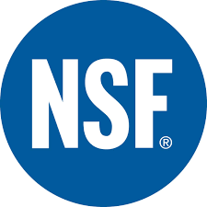 Color observed ----------------------------------------------------------------------Clear and Bright---------------------------------------------------------------------------
NSF Registration ------ ------ ------ ------ 133557 133558 133559 133560 133561 133562 133563 133564 133565
PIN # 17490 17495 17497 17498 17500 17524 17503 17505 17507 17513 17517 17515 17520
TO ORDER or FOR ADDITIONAL INFORMATION

